SmartInternz

www.smartinternz.com

CANCER MORTALITY AND INCIDENCE RATE PREDICTION - MACHCINE LEARNING

Project Hand-out, Faculty Development Program – NaanMudhalvan



Cancer Mortality and Incidence rate prediction Using ML

INTRODUCTION

# Project Overview:

This project aims to create a model that can predict how many people may die from cancer and how many new cases may occur. The model uses information about different areas, like population characteristics, healthcare access, and environmental factors.First, we look at the data and find patterns to understand how different factors relate to cancer rates. We also check for any missing or unusual data.

Then, we prepare the data by making sure it's in the right format. We split it into two parts: one for training the model and one for testing its accuracy.To make predictions, we use the Naive Bayes algorithm. It's a simple and effective method that looks at similar areas to estimate the cancer rates for a specific location.

To improve the accuracy of our model, we balance the data by creating synthetic examples using the RandomSpace technique. This helps to address any imbalances in the dataset.

Once the model is trained, we test it on the data we set aside. We measure how well it predicts the mortality and incidence rates.

Finally, we analyze the results using metrics like precision, recall, and F1-score. These metrics tell us how accurate our predictions are and help us understand where the model might be making mistakes.

This project uses a simple algorithm to predict cancer mortality and incidence rates. By analyzing data on different areas and using the RandomSpace technique to balance the data, we aim to make accurate predictions. These predictions can be helpful for planning public health initiatives and allocating resources effectively.

# Purpose

This project is being conducted to help predict and understand the number of people who may die from cancer and the number of new cases of cancer in different areas.

The goal of this project is to use data analysis and modeling to make accurate predictions about cancer deaths and new cases. This information can be used to plan better healthcare services, develop strategies to prevent and treat cancer, and ultimately improve the overall health of people affected by cancer.

IDEATION AND PROPOSED SOLUTION

**EMPATHY MAP**



**PROBLEM STATEMENT**





**BRAINSTROMING**

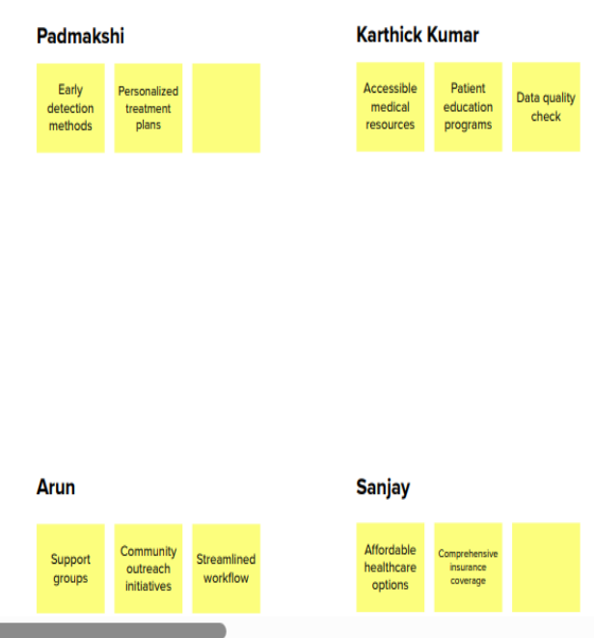

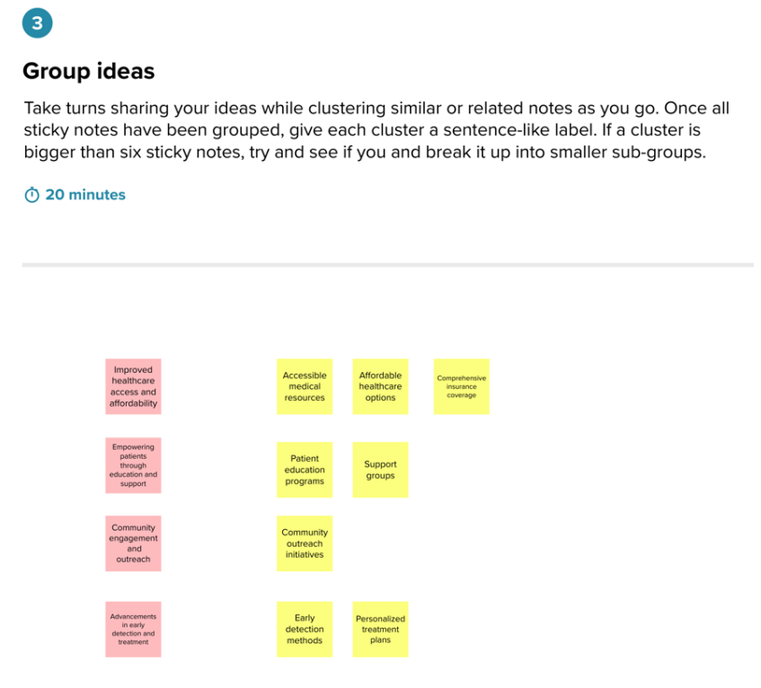

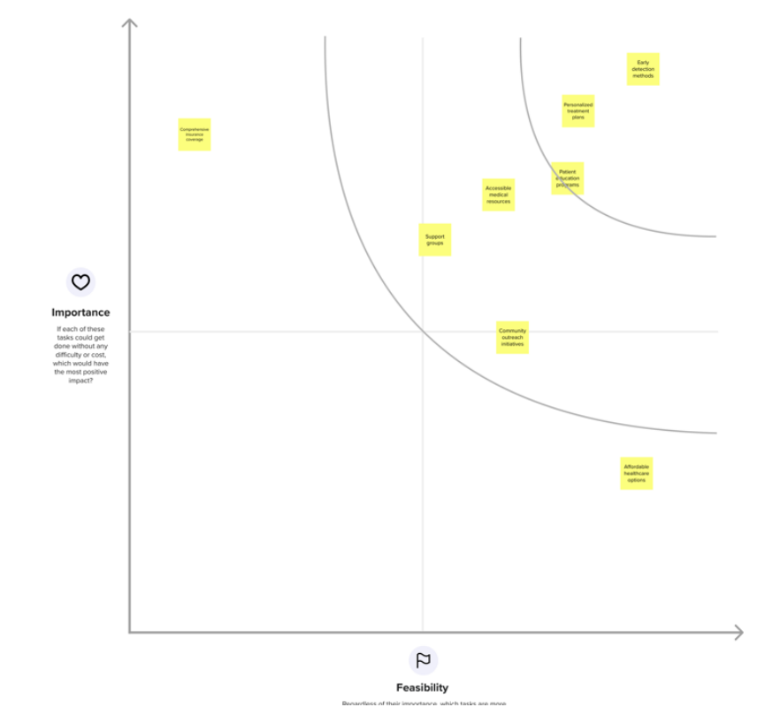

**PROPOSED SOLUTION**

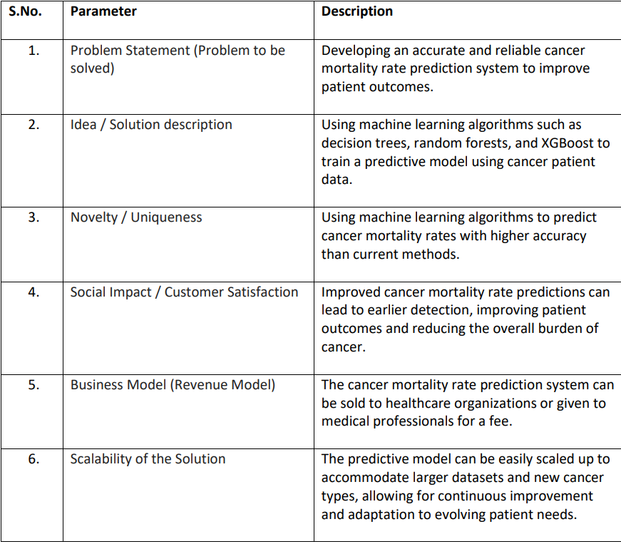

**REQUIREMENT ANALYSIS**

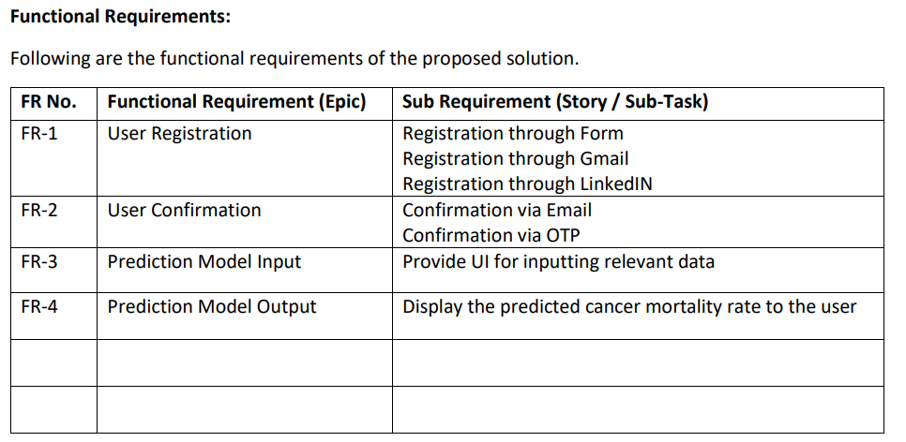

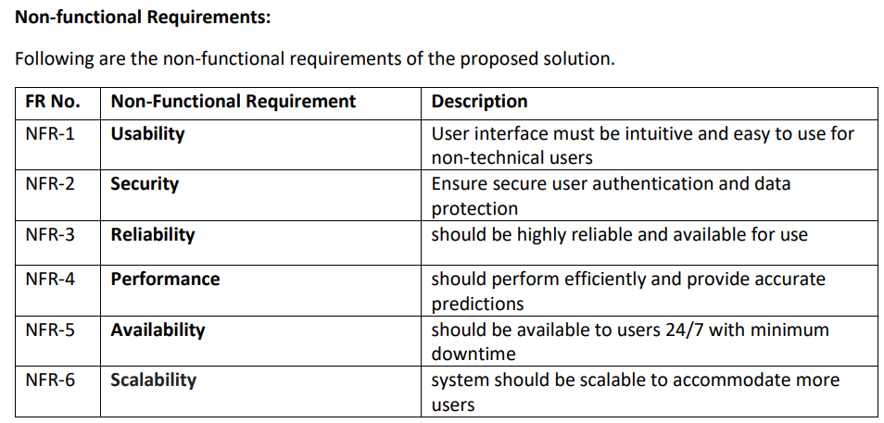

**PROJECT DESIGN**

**DATA FLOW DIAGRAM**

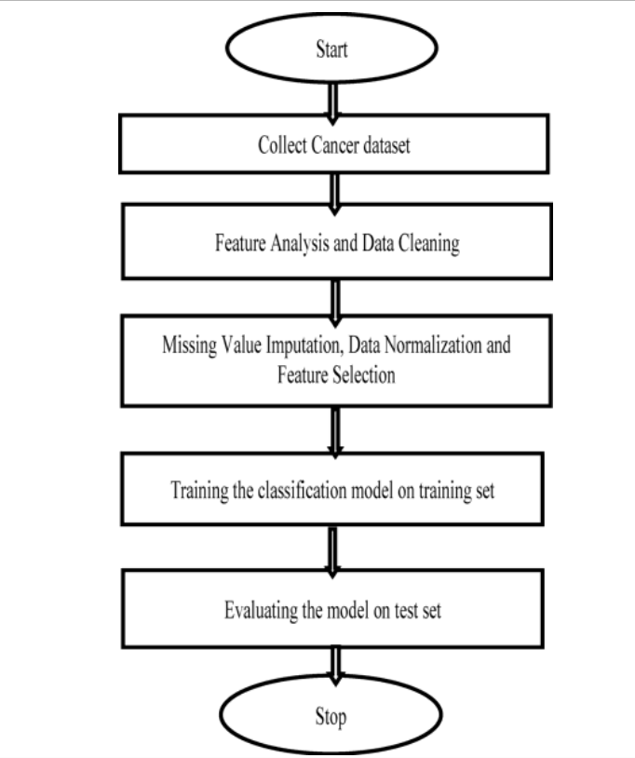

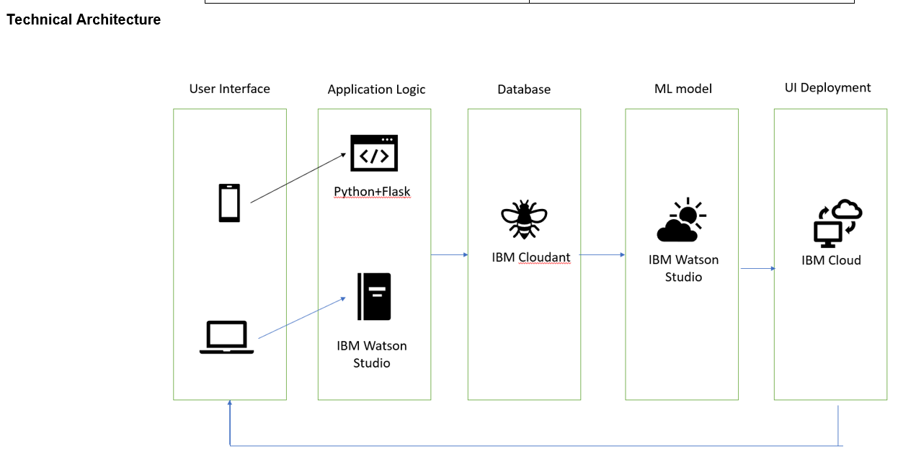

**USER STORIES**

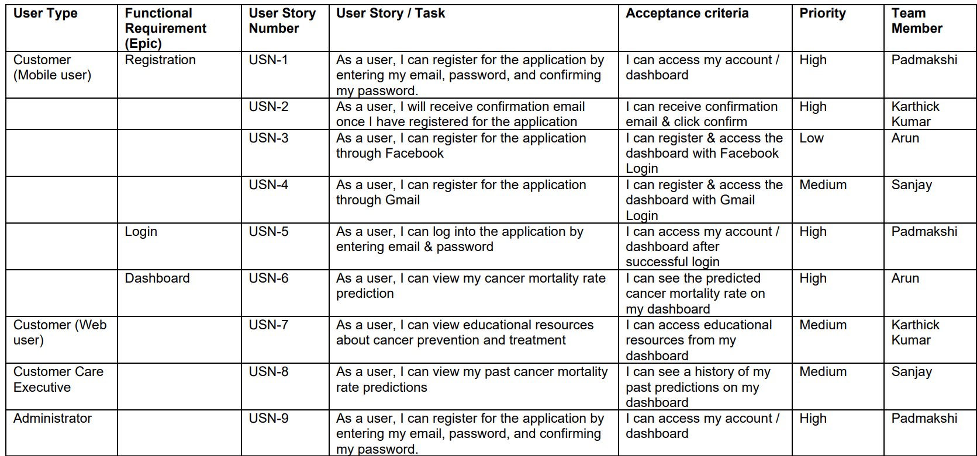

**CODING AND SOLUTIONING**

**Feature 1:**

**Prediction Form: The HTML form allows users to enter various input fields related to cancer mortality and incidence rates. These input fields include index, FIPS, met objective, death rate, lower and upper confidence intervals for death rate, average deaths per year, recent trend, recent 5-year trend in death rates, and lower and upper confidence intervals for trend. Users can input these values to make a prediction.**

**Code Example:**

**html**

**Copy code**

**<form action="{{ url_for('predict') }}" method="POST">**

**<div class="inp">**

**<div class="col1">**

**<!-- Input fields for various parameters -->**

**</div>**

**<div class="col2">**

**<!-- Input fields for additional parameters -->**

**</div>**

**</div>**

**<center>**

**<button type="submit" class="btn btn-success btn1">Submit</button>**

**</center>**

**</form>**

**5.2 Feature 2:**

**Prediction Display: If a prediction is available, it is displayed on the page. The predicted result is shown in a highlighted box with the label "The Cancer Mortality Incidence Status." Additionally, the status of the prediction is displayed, indicating whether the prediction was successful or not.**

**Code Example:**

**html**

**Copy code**

**{% if prediction %}**

**<h1>The Cancer Mortality Incidence Status:</h1>**

**<p id="prediction">{{ prediction }}</p>**

**<p>Status: {{ status }}</p>**

**{% endif %}**

**RESULTS  
**

**Advantages:**

**User-friendly interface for easy interaction.**

**Predictive functionality for cancer mortality and incidence rates.**

**Integration with Bootstrap for responsive design.**

**Disadvantages:**

**Lack of validation and error handling for user inputs.**

**Limited documentation and comments for code understanding and maintenance.**

**CONCLUSION**

**In conclusion, the project "IBM Oncology" is a user-friendly web application that allows users to predict cancer mortality and incidence rates. It provides a simple and intuitive interface for users to input relevant data and obtain predictions. The integration with Bootstrap ensures a responsive and visually appealing design.**

**However, it is important to consider certain limitations of the project. There is a need for improved validation and error handling to enhance the robustness of the application. The lack of comprehensive documentation and comments may pose challenges for future maintenance and development.**

**Overall, the "IBM Oncology" project offers valuable functionality for predicting cancer-related statistics.**

## Future Scope

* Telemedicine integration for virtual consultations
* User-friendly mobile app development
* Collaborative research partnerships for data-driven insights

SOURCE CODE:  
ipynb file:  
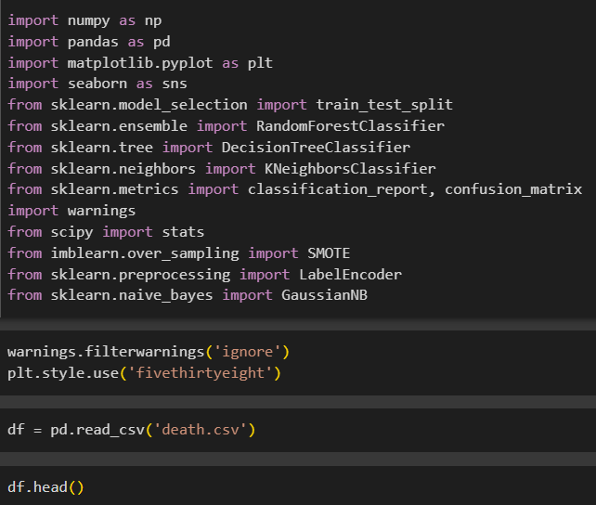

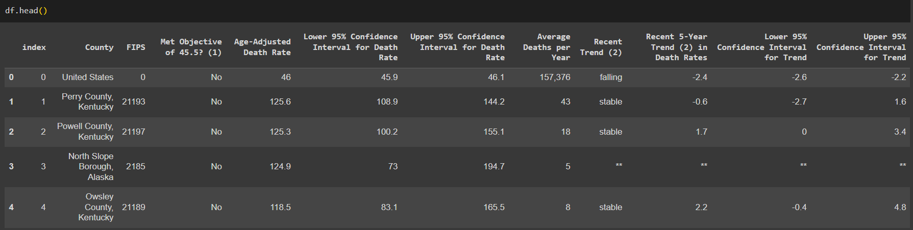

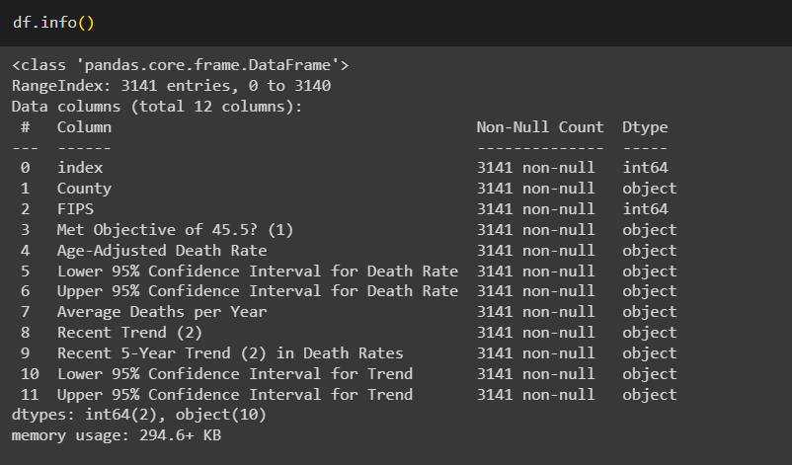



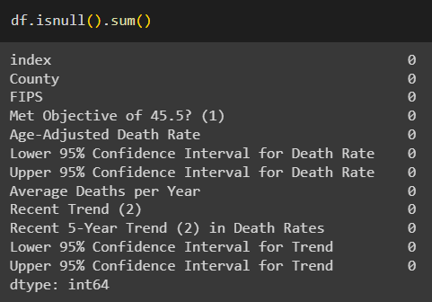



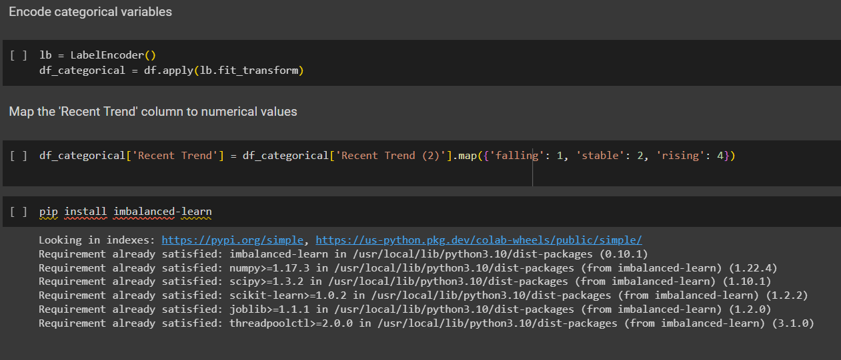

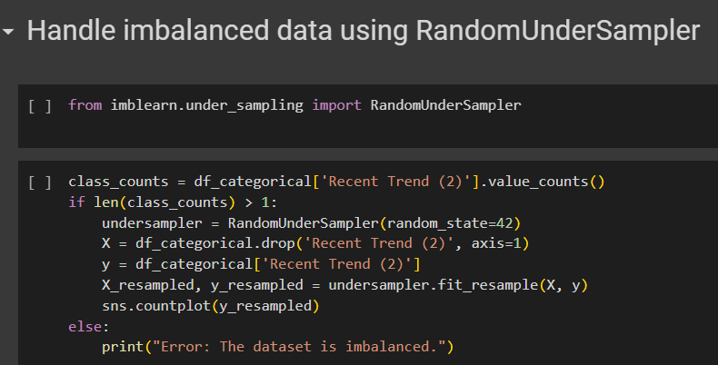 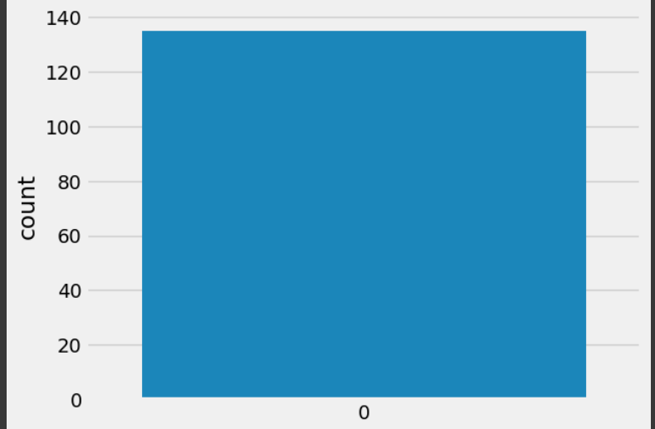



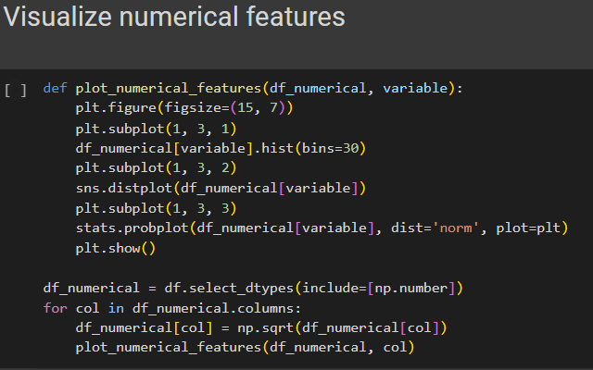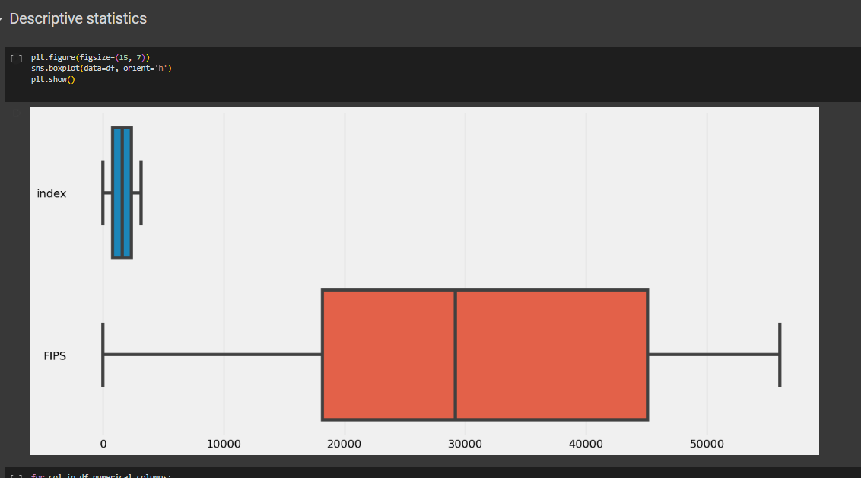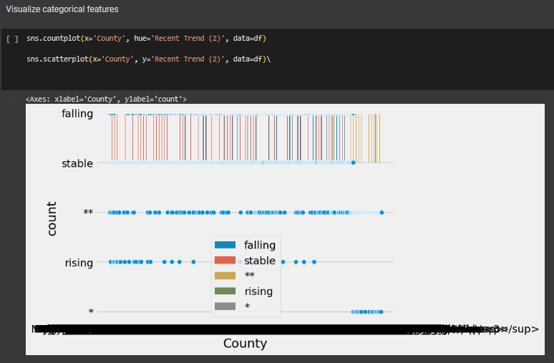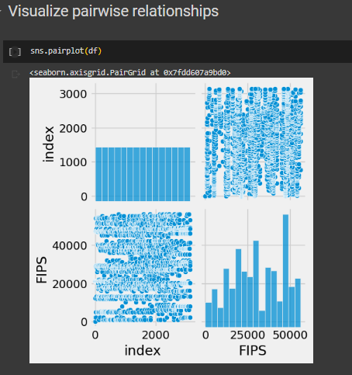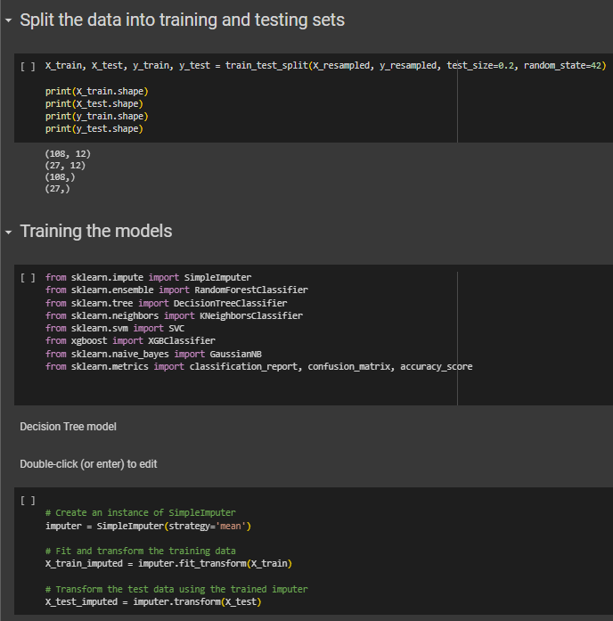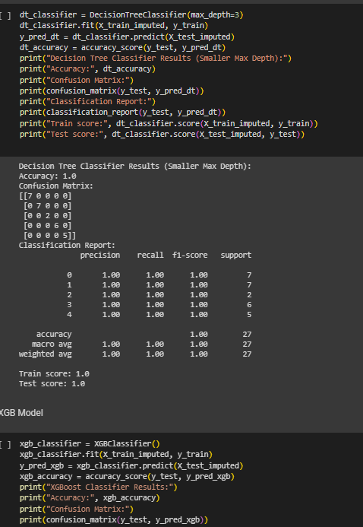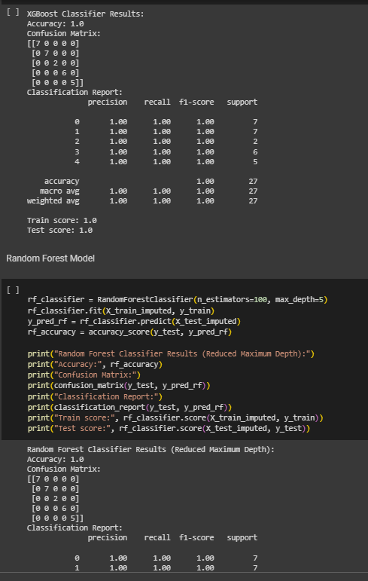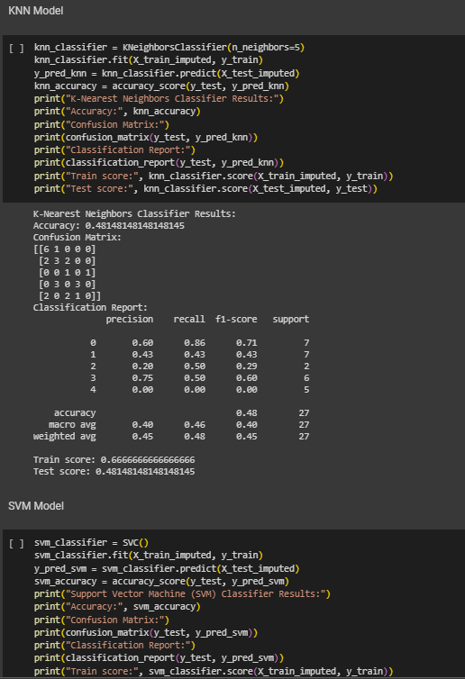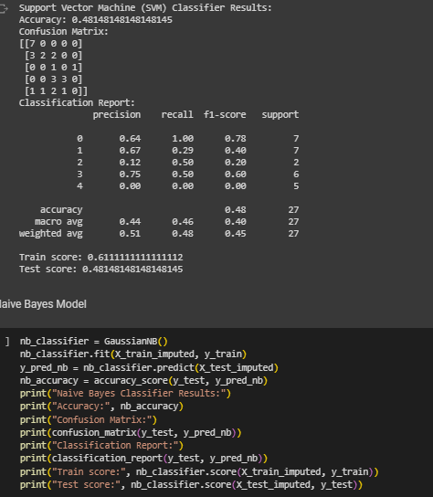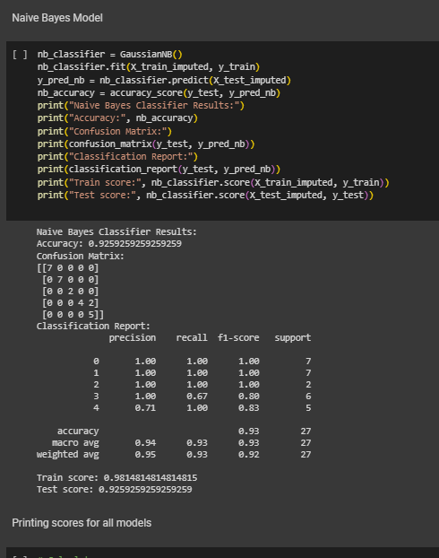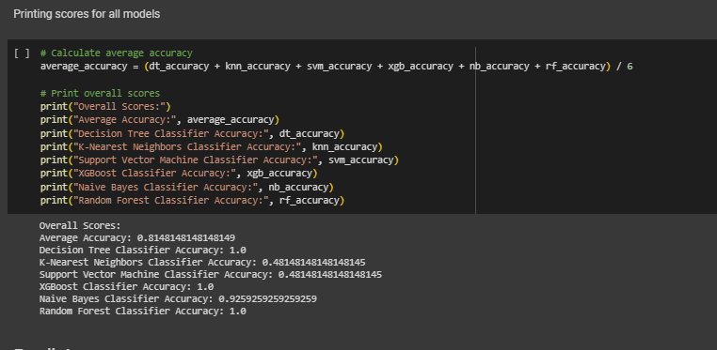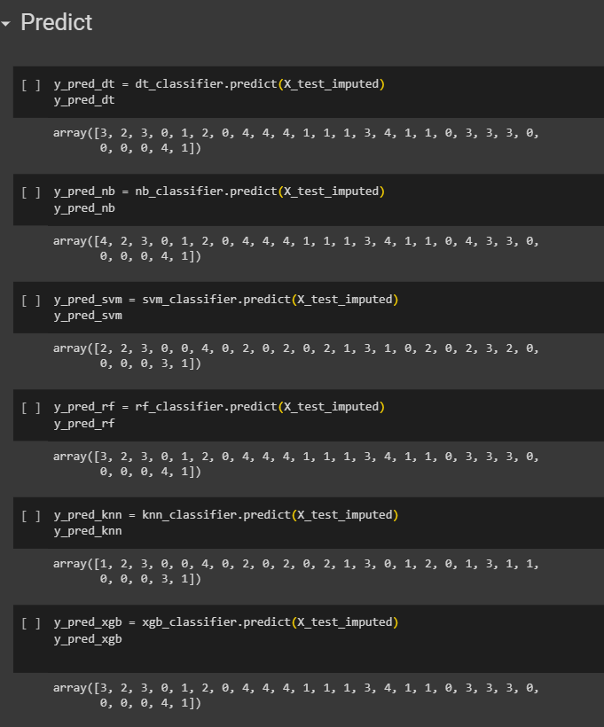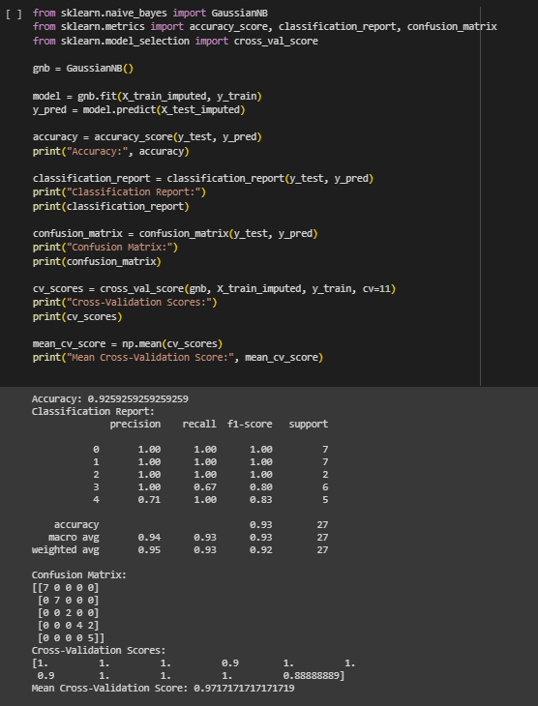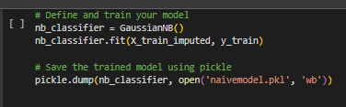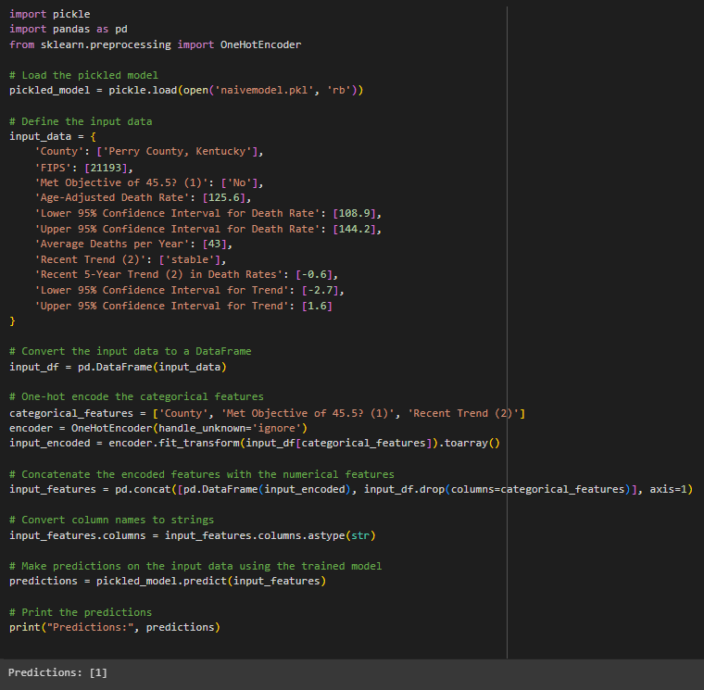

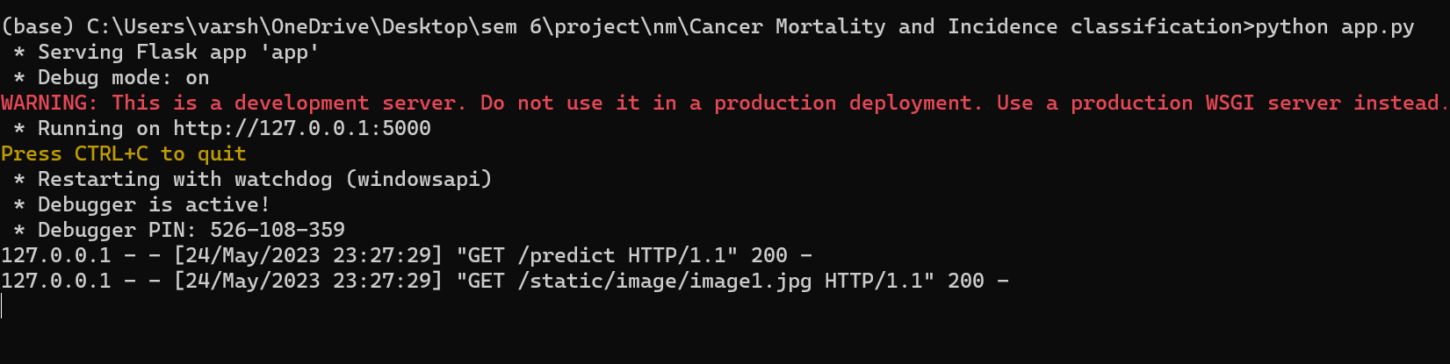



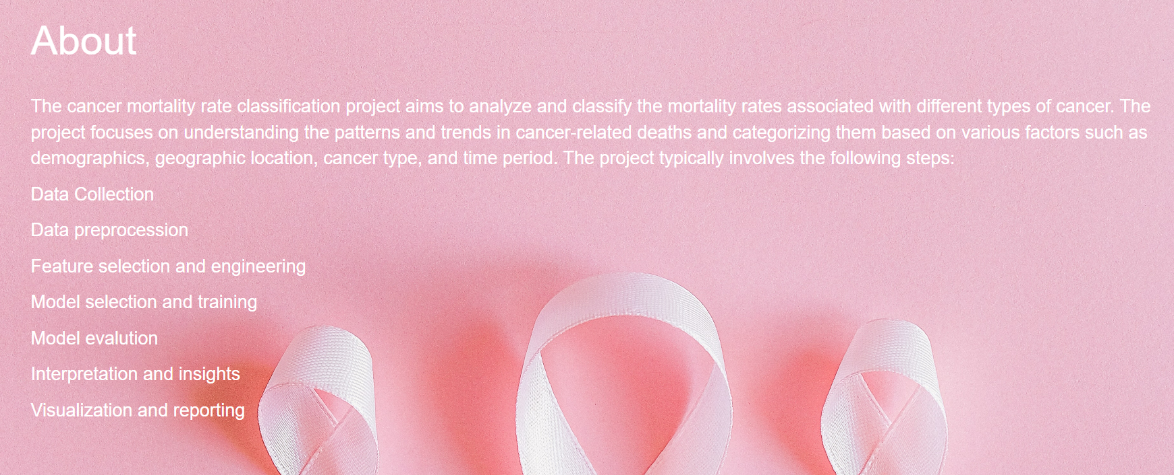





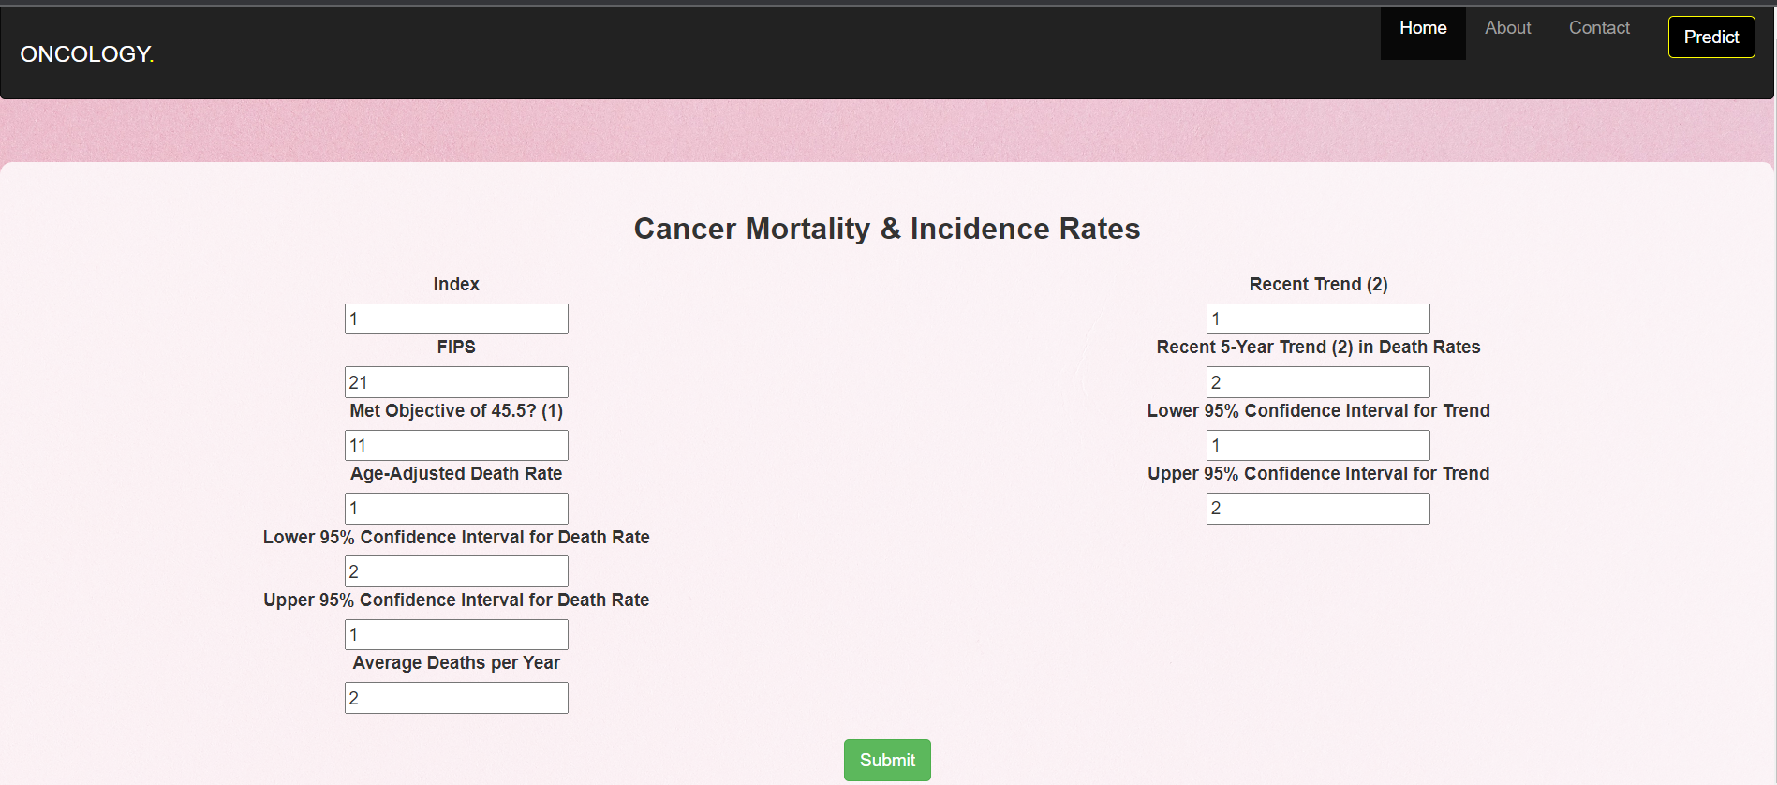

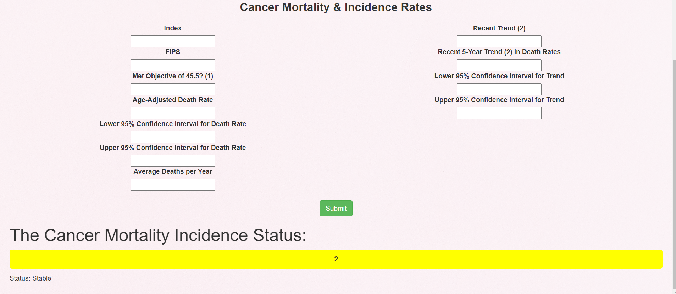

Github link:   
<https://github.com/naanmudhalvan-SI/IBM--17641-1682573202/tree/main>

Video demo:  
<https://drive.google.com/file/d/19xbCiPrcsBLFyjYvgWFrLGe6SeHr9Jy4/view?usp=sharing>